A Capstone Project Entitled

**ePahiram - (Micro Loans)**

*System Documentation*

Presented & Developed By:

Coligado, John Jason M.

Pandanan, Jhansept Kylo

April 2023

**Table of Contents**

**Title Page**

Table of Contents………………………………………………………………………………2

Introduction.....................................................................................................................3

Project Description…………………………………………………………………………….4

Project Scope.........................………………………………………………………………..5

Expected Acceptance Criteria....................................................................................9

Project Limitation (Out of Scope) ................................................................................10

Entity Relationship Diagram.........................................................................................12

System Flowchart..........................................................................................................13

System Architecture......................................................................................................16

Tools & Frameworks............................................................................................19

Packages............................................................................................................19

Wireframes.....................................................................................................................20

User Guide......................................................................................................................29

Admin Guide.................................................................................................................36

API Documentation......................................................................................................40

**Introduction**

ePahiram is a loan management system that offers a hassle-free and convenient way for individuals to loan gadgets and calculate monthly payments. In a world we’re keeping up with the latest technology trends can be difficult, ePahiram provides a solution by allowing users to apply for a loan to purchase the gadget they need. The system is equipped with a Loan Calculator feature that helps users make informed decisions before applying for a loan, while the Gadget Loan feature simplifies the loan application process, making it more convenient for users. ePahiram is designed to provide a seamless user experience, the ePahiram system is designed using CSS and Bootstrap.

. Overall, ePahiram is a timely solution that makes it easy and convenient for users to loan gadgets and manage their finances effectively.

**Project Description**

ePahiram is a loan management system that addresses the needs of individuals who are looking for a convenient and hassle-free way to loan gadgets and calculate monthly loan payments. In today's fast-paced world, people often need to keep up with the latest technology trends, but they may not always have the means to do so. ePahiram provides a solution by allowing users to apply for a loan to purchase the gadget they need, with a manageable monthly payment based on their preferred payment term.

ePahiram's Loan Calculator feature enables users to make informed decisions before applying for a loan, ensuring that they are comfortable with the monthly payment based on the loan amount and term they prefer. This feature makes it easy for users to plan their finances and manage their budget effectively.

The Gadget Loan feature of ePahiram simplifies the process of applying for a loan, with an approval process to ensure qualified applications. This feature eliminates the need for users to go through a lengthy loan application process, making it convenient for them to loan the gadget they need.

The ePahiram system is built with several project deliverables, including an ASP .NET Core 6.0 MVC Web App, a Web API, and an SQL Server database. To ensure a seamless user experience, the ePahiram system is designed using CSS and Bootstrap.

**Project Scope/Requirements**

**In Scope:**

The ePahiram project scope aims to provide a loan management system that caters to individuals who are looking for a convenient and hassle-free way to loan gadgets. The system features a Loan Calculator that allows users to make informed decisions before applying for a loan, ensuring that they are comfortable with the monthly payment based on their preferred loan amount and term. The Gadget Loan Application feature simplifies the process of applying for a loan, with an approval process to ensure qualified applications.

**Web Services (API)**

* + Authentication
    - JWT Token
  + Gadget Loan
    - CRUD

**Web Application (MVC)**

**User Side**

* Authentication and Authorization
  + Register
  + Log in and Logout
  + View Profile
  + Change Password
* Home
  + Loan Calculator
  + Gadget Loan
* Loan Calculator
  + Calculate Monthly Loan Payments
* Gadget Loan
  + Search
  + View All Gadgets
  + Apply for Gadget Loan
* My Purchase
  + View Gadget Loan Application
  + Withdraw Gadget Loan Application

**Admin Side**

* Authentication and Authorization
  + Log in and Logout
  + View Profile
  + Change Password
* Gadget Loan
  + Search
  + CRUD
* Manage Users
  + View All Registered Users
  + Delete User
* View Purchases
  + Search
  + View All Gadget Loan Applications
  + Approve and Decline Gadget Loan Application

**Functional Requirements**

The requirements in this document are divided into the following categories:

**System Requirement**

|  |  |  |
| --- | --- | --- |
| **Item** | **Rating** | **Description** |
| Login/Registration/ Logout | High | User will be able to login and logout with their provisioned account details. Also, able to register new accounts. |
| Dashboard for user and admin | High | * Dashboard for user, to view the given loans and requirements * Dashboard for admin, to view purchases of the loan * Manage Application Status (Admin) |
| Purchases | High | List all Existing and archived purchases of the loan(admin) |
| My Purchase | High | Details for purchase made by the user whether existing or archived |
| Gadget Loan | High | Provides list of terms, interest, and available gadgets for loan. Also, payment computation for the chosen entity. |
| Account Roles | High | -User must perform the indicated features for purchase, compute loan and views gadget loans. -Admin has the privilege to add Gadget Loan, update details, delete, view purchases history, and manage users |
| Loan Calculator | Low | Provide requirements and details for the loan (extra features) |

**Rest API**

|  |  |  |
| --- | --- | --- |
| **Item** | Rating | Description |
| Authentication | High | User will be able to login with his provisioned account details. |
| Gadget Loan Crud | High | API’s to access the database of the gadget loan and manage it using CRUD operation. |

**Expected Results**

* **Loan Calculator:** tool that helps users to estimate the amount of money they will have to pay each month to repay a loan based on the loan amount and the loan term they prefer. The user can input the loan amount and the preferred loan term (in months), and the calculator will compute the monthly payment and display the total amount payable. This helps the user to determine whether they can afford to make the loan payments and decide whether to proceed with the loan application.
* **Gadget Loan:** allows users to apply for a loan to purchase a gadget of their choice. However, users can only apply for one gadget at a time. The system admin has the authority to approve or decline user gadget loan applications. The admin has the capability to add a gadget for loaning by providing the gadget name, description, price, and image URL. The gadget will then be made available for users to apply for a gadget loan. The admin can also delete a gadget from the system. If the admin deletes a gadget, all the gadget loan applications associated with that gadget will also be deleted.
* **Manage User Accounts:** The admin can view the user details and has the authority to delete the user's account from the system.
* **View Purchases:** The admin can view all the purchases made by the user and can approve or decline the user's loan applications. If the admin declines or if the user withdraws the loan application, it will be stored in the Archived Purchases section of the system. This feature helps the admin to manage the user accounts efficiently and provides a convenient way to view the user's loan history. All approved application will still be visible in the purchases section.
* **Profiles**: Users and Admins have access to their respective profiles where they can view their personal details such as name, email, gender, birthdate, address and contact information. Users and admin can also change their password from their profile settings. However, the system does not allow users or admin to modify any other user profile details other than their own. This ensures the security and privacy of each user's personal information. Additionally, this feature provides a convenient way for users and admin to manage their profile information and update their password if necessary.
* **API**: perform CRUD operations for the system administrator; additionally, the API uses JWT token authentication for the security of API calls that may reflect changes to the main system.

**Out of Scope:**

* **Loan Calculator:** The loan calculator does not actually apply for a loan on behalf of the user; it only provides an estimate of the monthly payments.
* **Gadget Loan:** The system does not handle the process of how the user will pay for the gadget or receive it. The system only provides an approval process to ensure that users are qualified to loan the gadget they applied for.
* **Gadget Inventory:** Inventory management for the quantities and availability of the gadgets in the gadget loan.
* **User Qualification:** The system does not have any pre-set criteria or requirements for determining the eligibility of users for gadget loans.
* **Responsiveness:** The system is designed for desktop and laptop screens. Usage of smaller screen may affect system design.

**Entity Relationship Diagram**

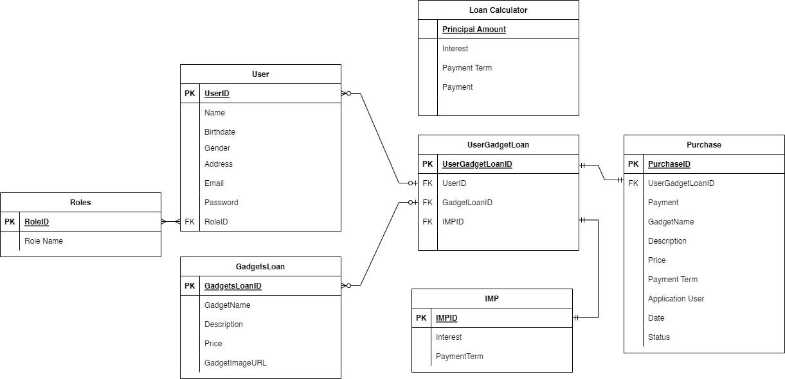

The entity relationship diagram shows the graphical representation of the relationship of each entity. The ePahiram has the entities Roles, User, GadgetLoan, UserGadgetLoan, IMP (Interest Monthly Payment), Purchase and Loan Calculator. The user has a one-to-one relationship with the roles. Also, the user has a one-to-many relationship with the UserGadgetLoan as well as with the GadgetLoan. IMP and Purchase has a one-to-one relationship with the UserGadgetLoan. The Loan Calculator doesn’t have relationship with the other entities since it is just a process of computation.

**System Flowchart**

A system flowchart is a visual representation of the flow of data, information, and processes within a system. It is commonly used in system analysis and design to document the flow of information within a system and to aid in the identification of potential issues or areas for improvement.

In the context of the ePahiram: Loan Management System, a system flowchart could be used to illustrate how the system handles Gadget Loan applications, calculations, and approvals.

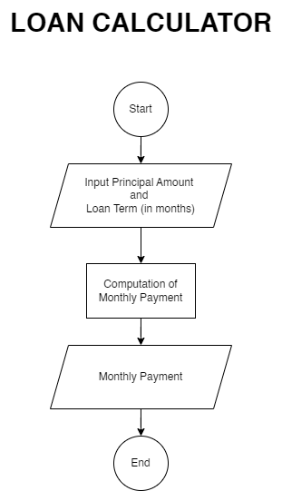

The Loan calculator flowchart starts by inputting the principal amount and loan term desired by the user, then the system will make the monthly computation and display it.

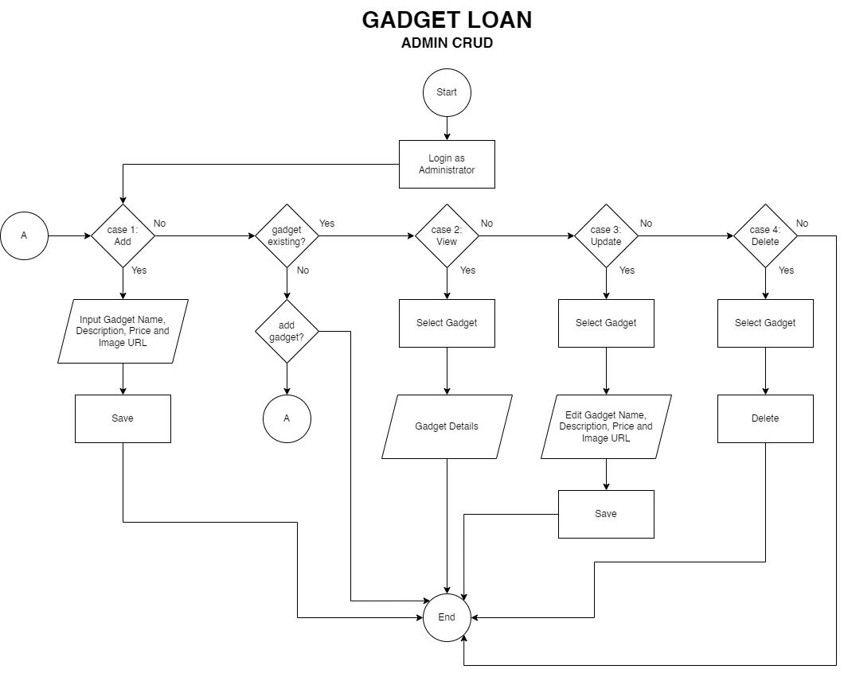

The flowchart of the Gadget Loan (Admin CRUD) shows how the user can add, view, update, and delete gadgets loans. It starts by Logging in as an administrator. To add a gadget, the admin must input the name, description, price and image URL, the system will then save the gadget. To View a gadget, the admin must select a gadget and the system will show its details. To update, the admin must select a gadget, edit the detail of the gadget and the system will save it. Lastly, to delete, the admin must select a gadget to be deleted and the system will delete it.

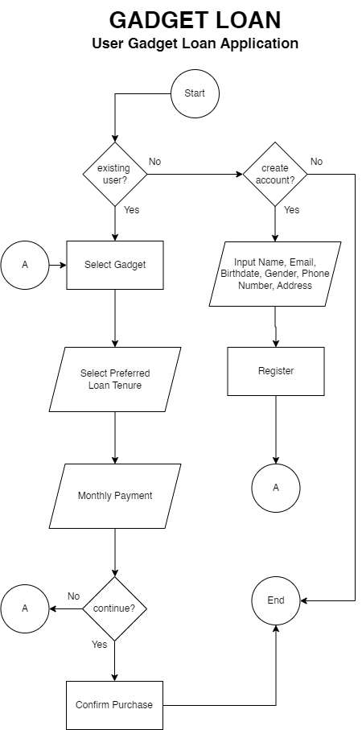

The flowchart Gadget Loan (User Gadget Loan Application) shows on how a user can apply a gadget loan. It starts by confirming if the user is existing, if not, the user must create an account by registering his/her name, email, birthdate, gender, phone number and address. After having an account, the user can now select a gadget, select his/her preferred loan tenure, the system will then show the monthly payment for the loan. If the user desires to pursue the application, the system will be confirming his purchase, if not, the user may once again select other gadget and proceeds with the same process.

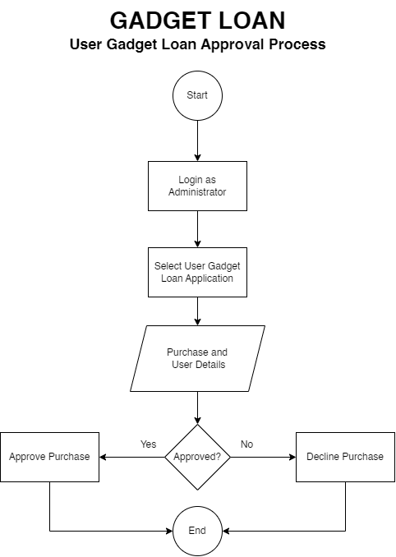

The flowchart Gadget Loan (User Gadget Loan Approval Process) shows the approval process of the user’s gadget application. It will start by logging in as an administrator. The admin will select a user gadget loan application in the purchases, the system will then show the purchase and user details. After having the details, the admin will decide whether the application will be declined or approved.

**System Architecture**

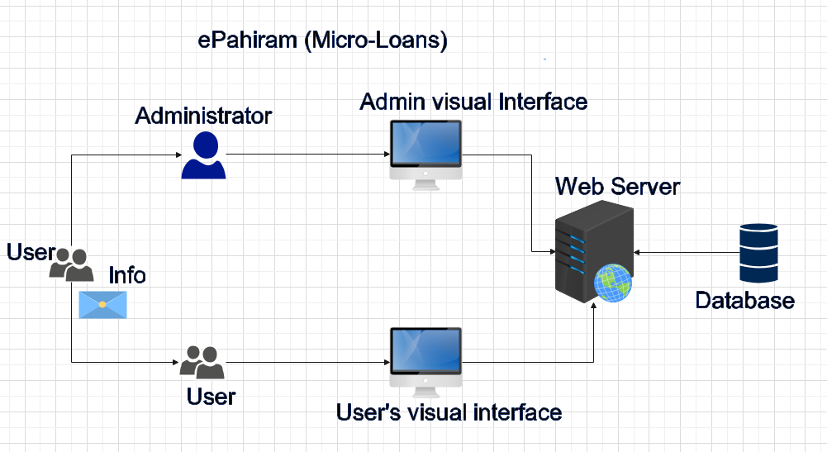

The diagram above depicts the ePahiram (Micro-Loan) system design. The figure is made up of various entities, each with its own set of critical features for the system. Each entity is described in detail below.

* **User:** The user entity is reliant on traveling through each system function, which include the loan calculator and gadget loan. Before using the system's capabilities, you may be required to fill out a registration form.
* **User Visual Interface:** All registered users get access to all of the gadgets that are offered for loan, including all of the required information about the chosen item and the available payment terms also the user can apply for loan application and withdraw it application if needed. Basic loan calculator calculations may also be performed.
* **Administrator:** The system administrator is capable of doing basic technical operations for the gadget loan, as well as managing all users registered with the system.
* **Admin Visual Interface:** The admin views will contain all of the registered users as well as all of the crud operations for the gadget. For any transactions done by the user, the admin has all of the records surrounding its purchase as well as the withdrawal application by the user.
* **Web Server:** All requests made by each system user will be handled by the webserver, which will also retrieve the necessary information from the database and supply it to the requests made by each user entity.
  + **Admin Visual Interface:** All of the pages and transactions requested by the administrator are routed through the server and retrieved from the database. This comprises all users, transactions, and data given to the gadget to retrieve from the database and return to the view.
  + **User Visual Interface:** All requests made by the user, such as gadgets, descriptions, available payment terms, purchase and withdrawal actions, will be processed by the server, and the appropriate information will be obtained from the database. It should be noted that the user can also access personal information pertaining to the current user purchase as well as the status of the loan application.
* **Database:** The database stores all of the information provided to each page of the interface, as well as the relationship between entities for the system. This is also where all user data is maintained,

**Tools & Packages**

All of the tools and packages required to build the system are listed below:

**Tools/Website/Documentation:**

* Visual Studio 2022
* MS SQL
* Bootstrap
* Draw.IO
* Microsoft Visual Studio C# Documentation
* Docker Hub

**Packages:**

* Automapper
* FluentAssertion
* ASP.NetCore Identity Entity Framework
* ASP.NetCore Design
* ASP.NetCore SQL Server
* ASP.NetCore Tools
* System Linq Dynamic Core

**Wireframes**

Attached below are the mock up design of the system interface and reference to the system requirements:

**Landing Page**

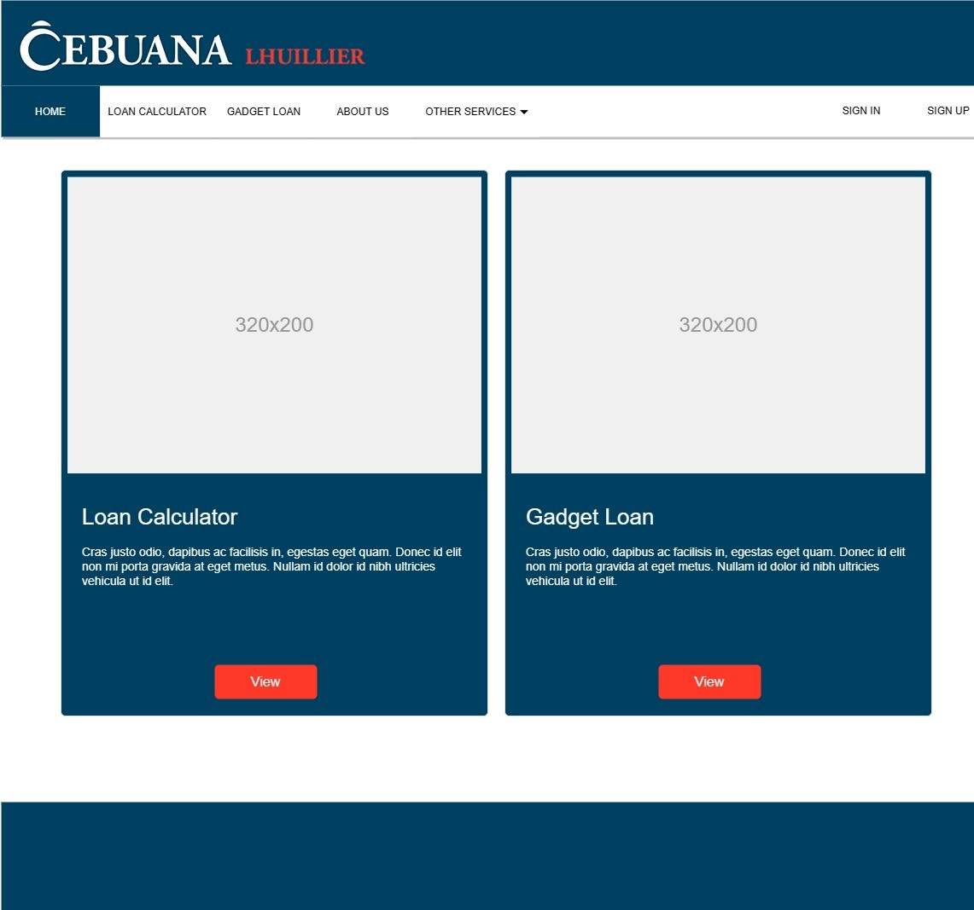

**Sign In Page**

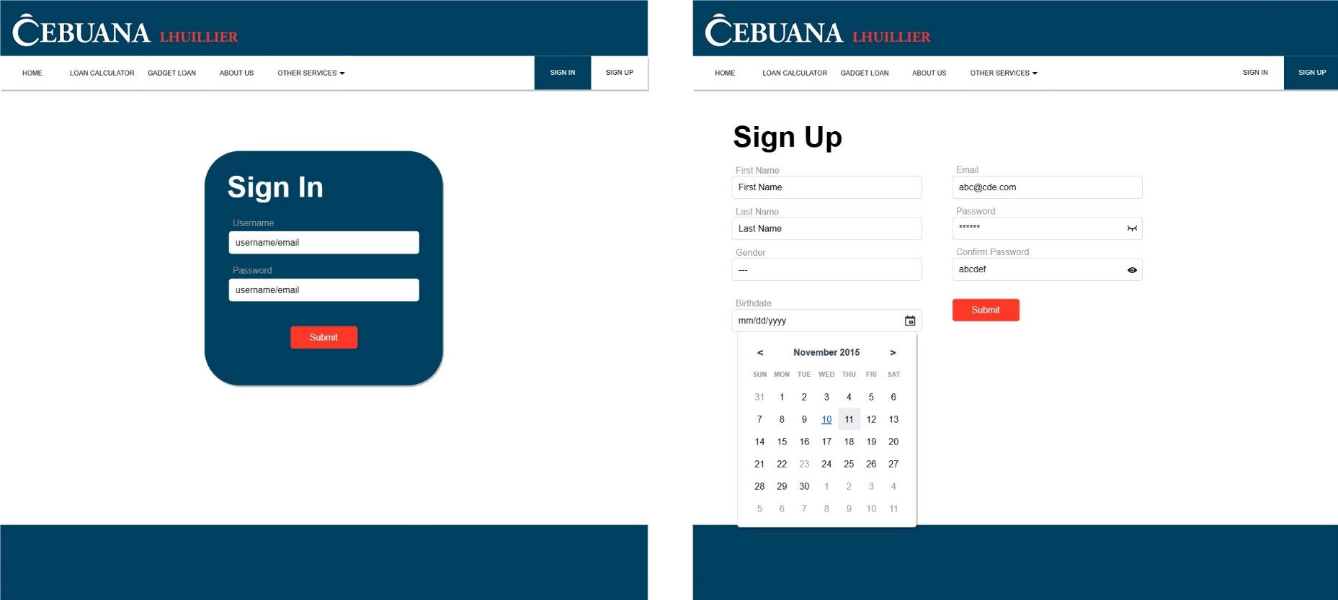

**Sign Up Page**

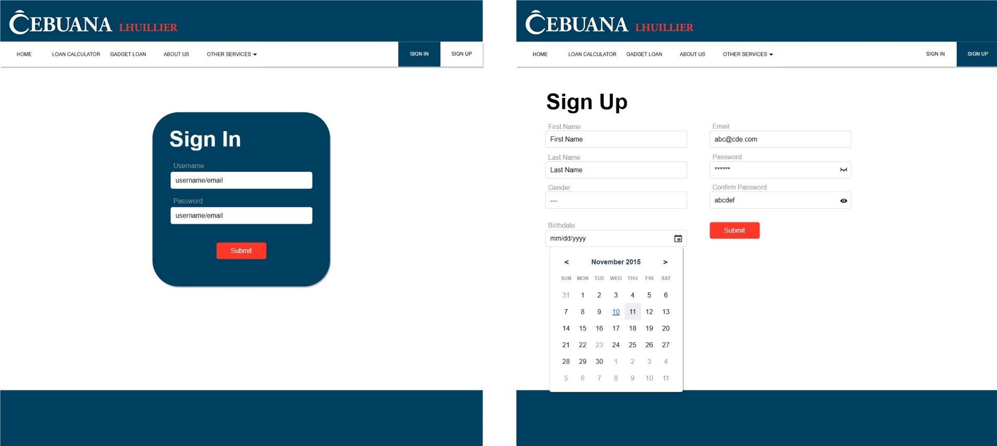

**Gadget Loan**

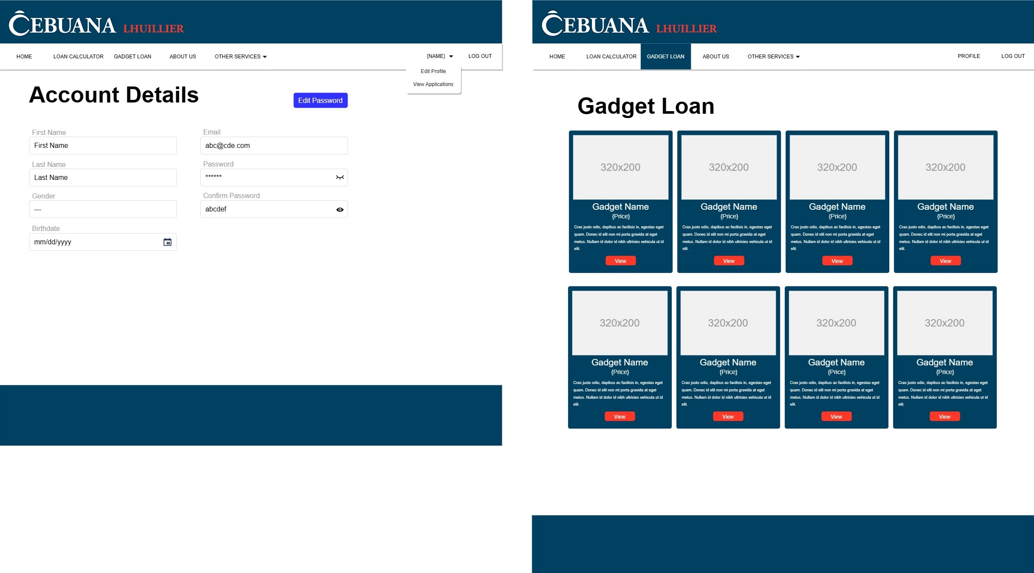

**Account Details**



**Gadget Loan**

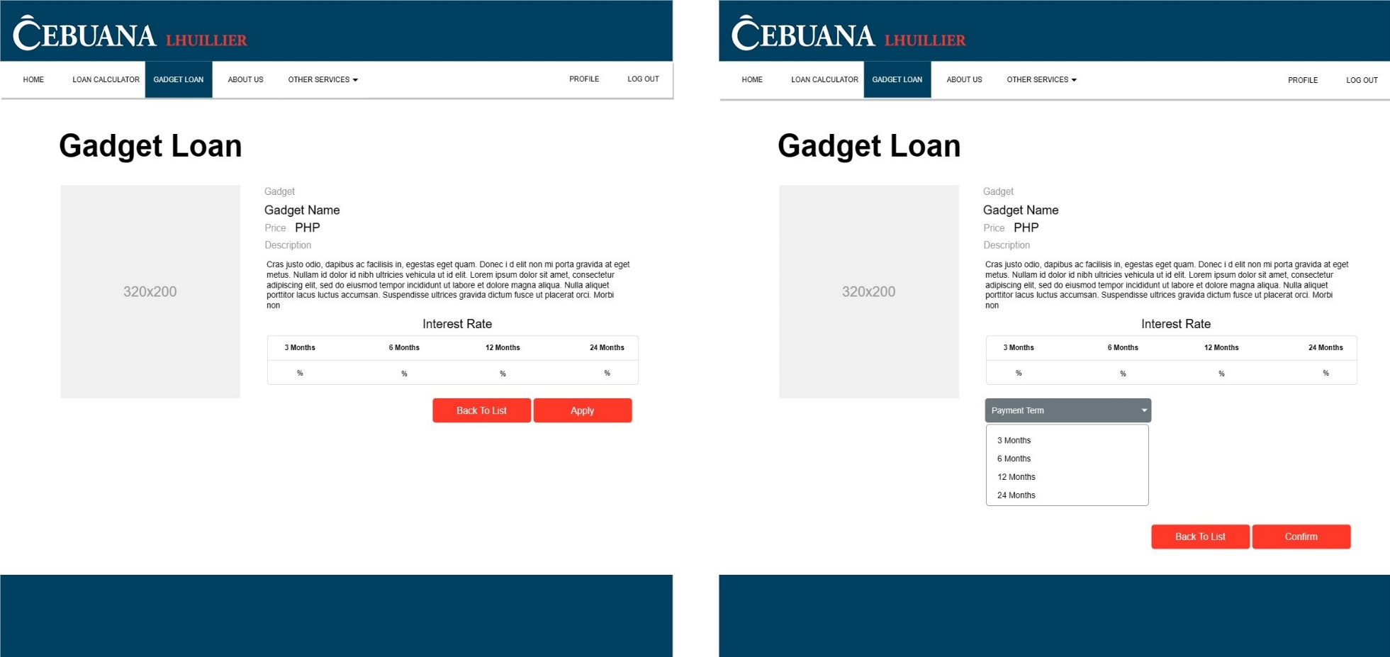

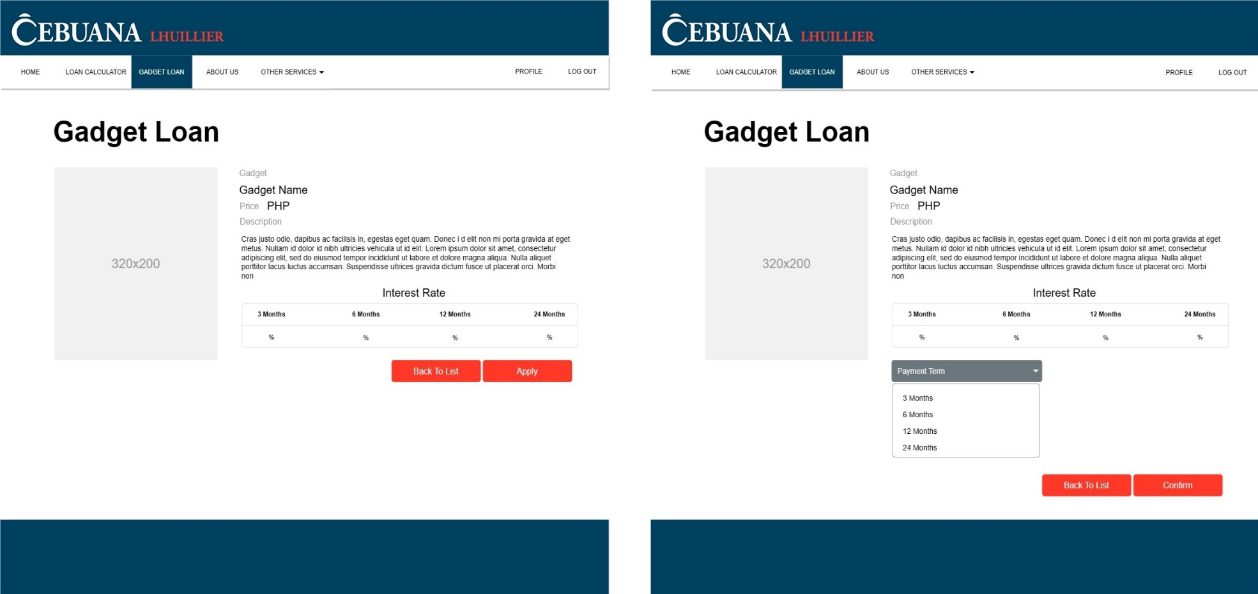

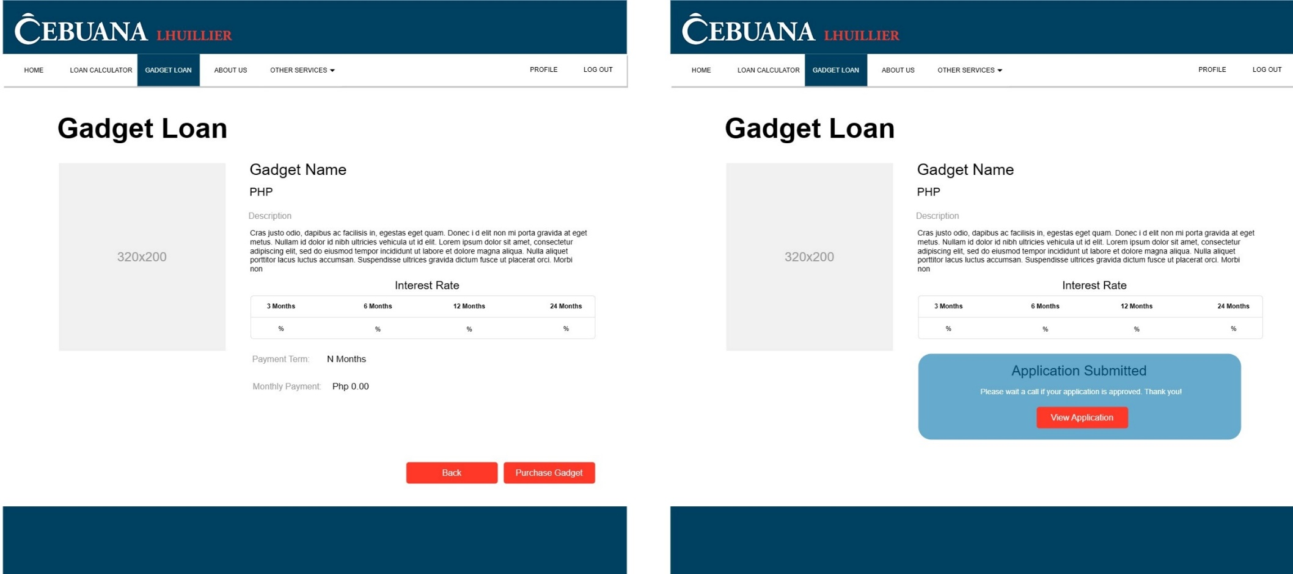

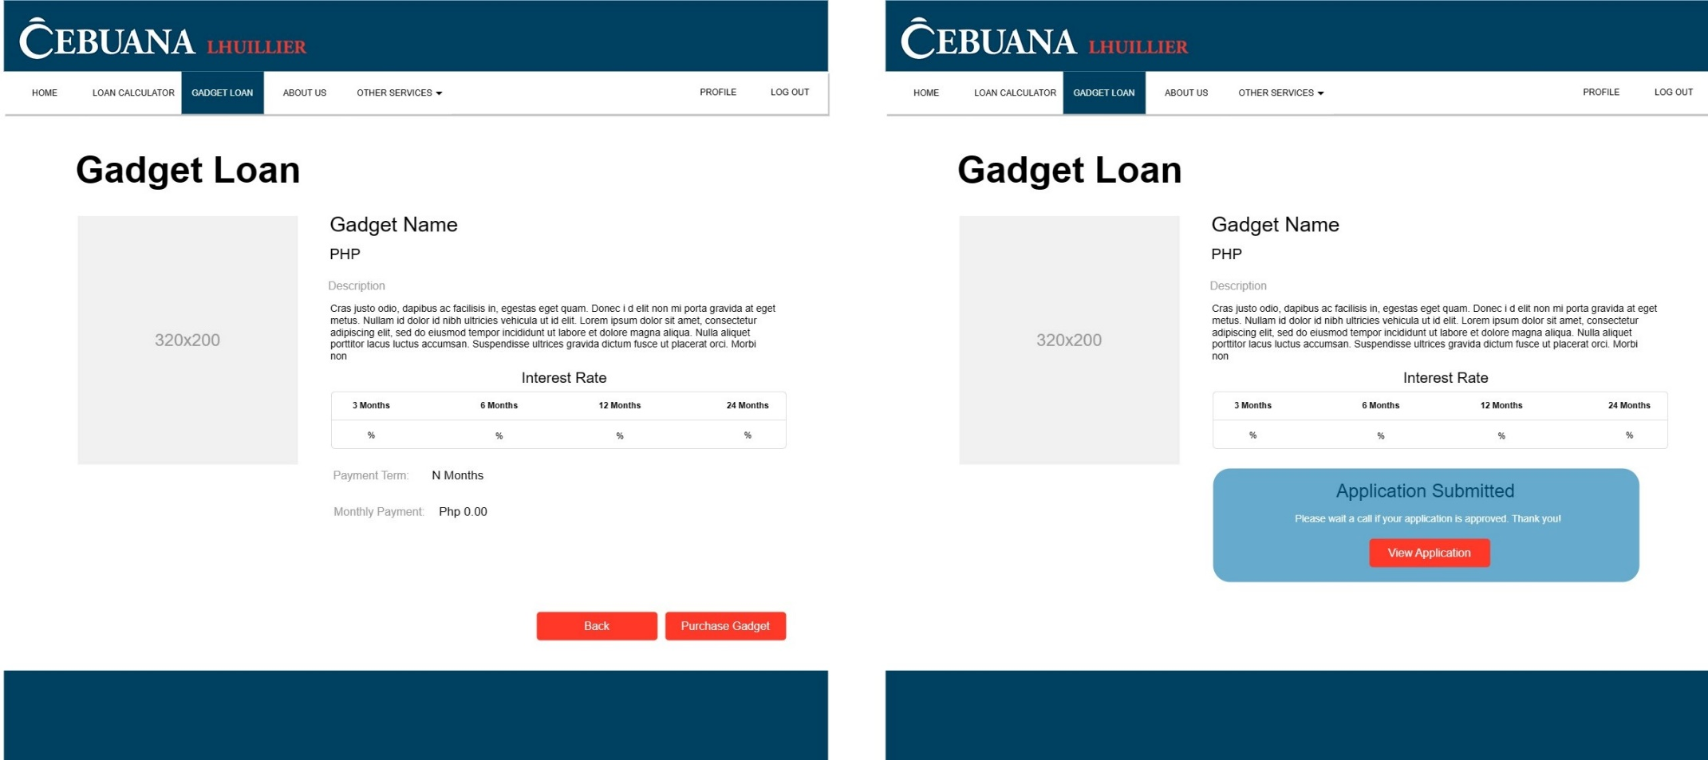

**Loan Calculator**

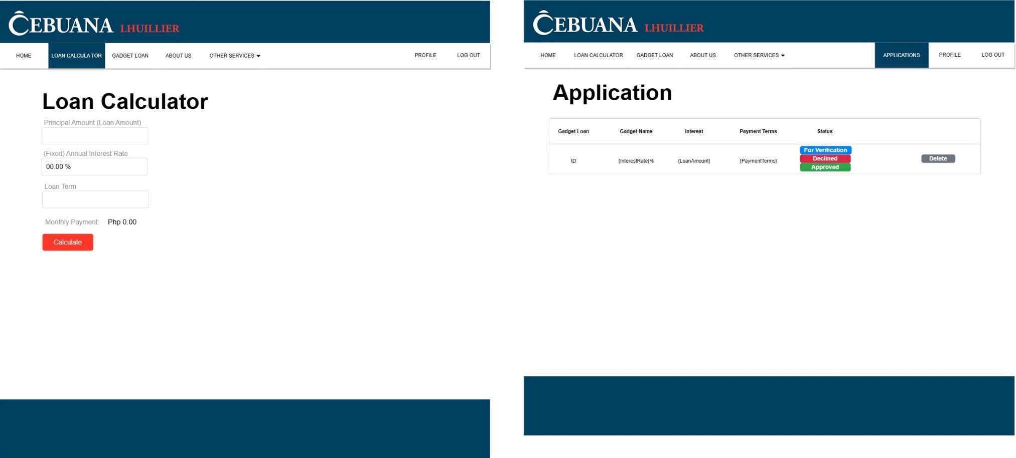

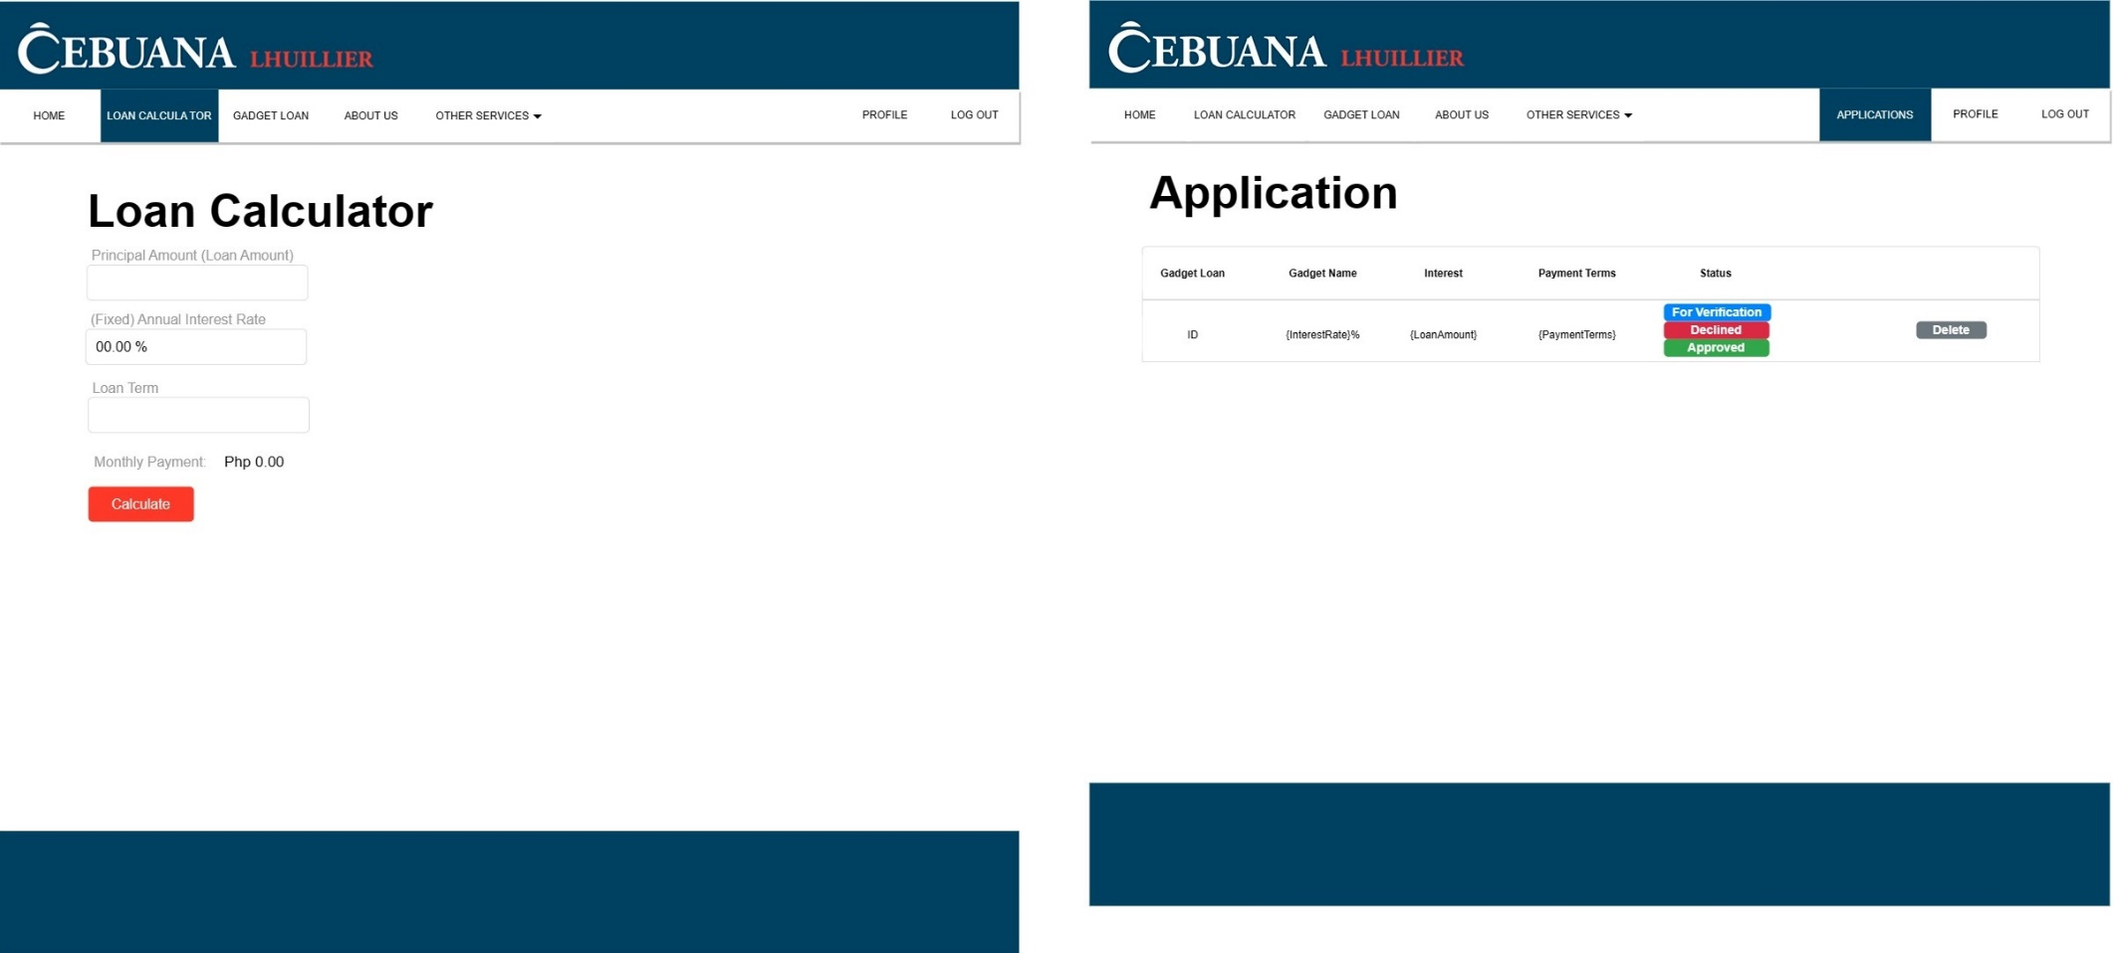

**Administrator Side**

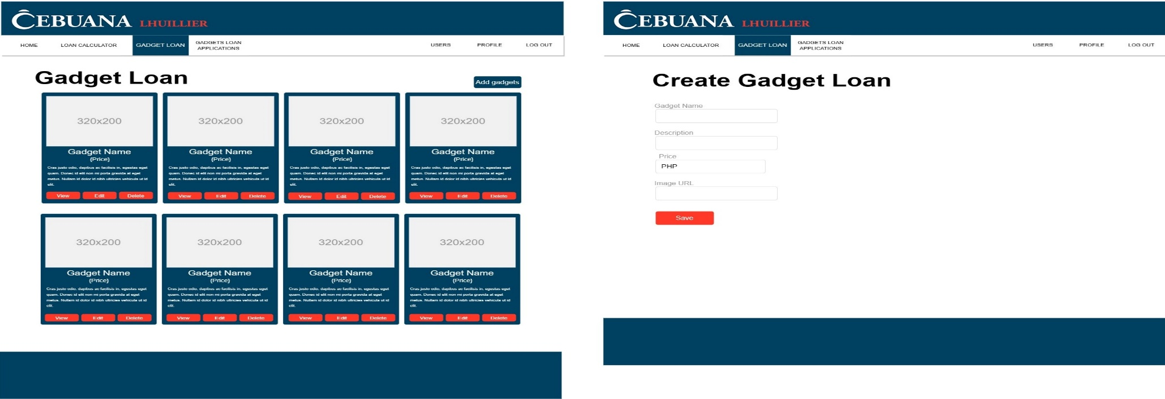

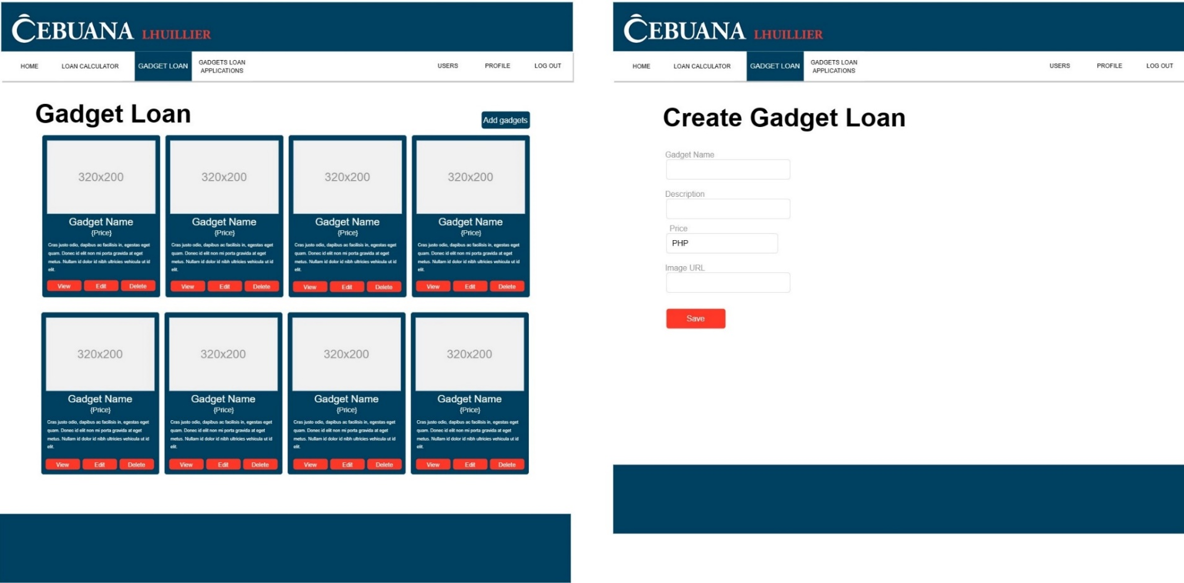

**Manage Purchases**

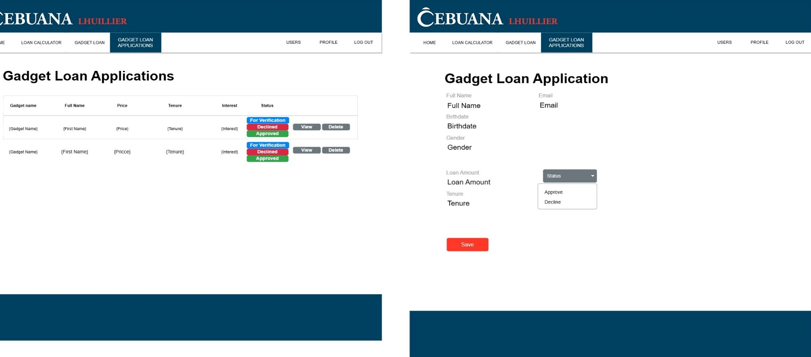

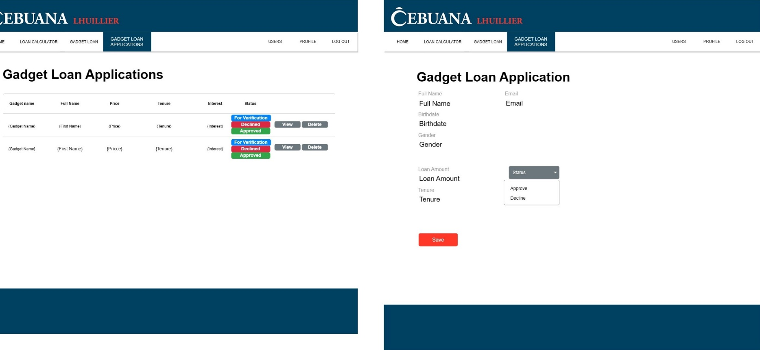

**User Guide**

**Home page**

Users can navigate using the menus provided in the page headings, or they can immediately click the see button of the features they want to explore.

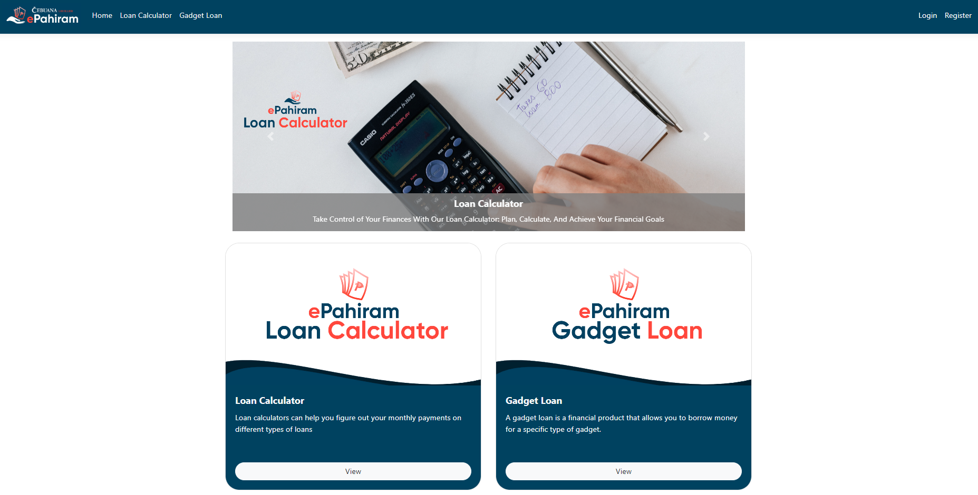

**Loan Calculator**

Loan Calculator is a system function that allows you to calculate your loans based on the parameters listed in the tables below.

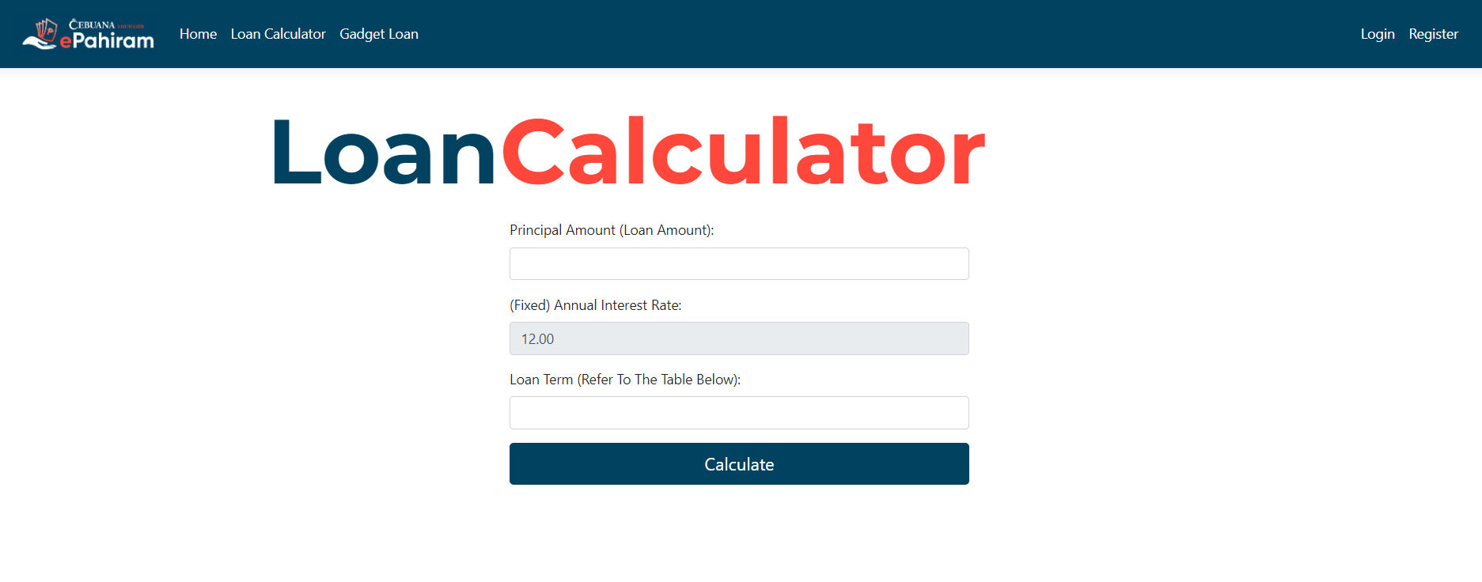

**Listed Criteria**

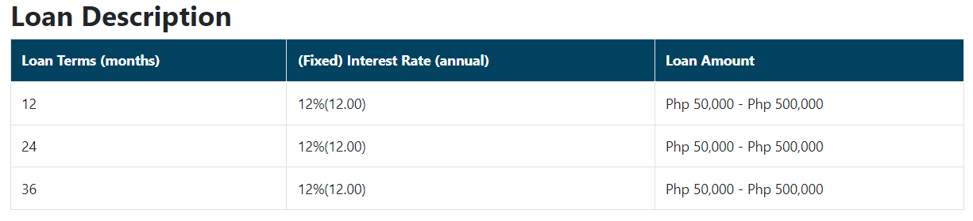

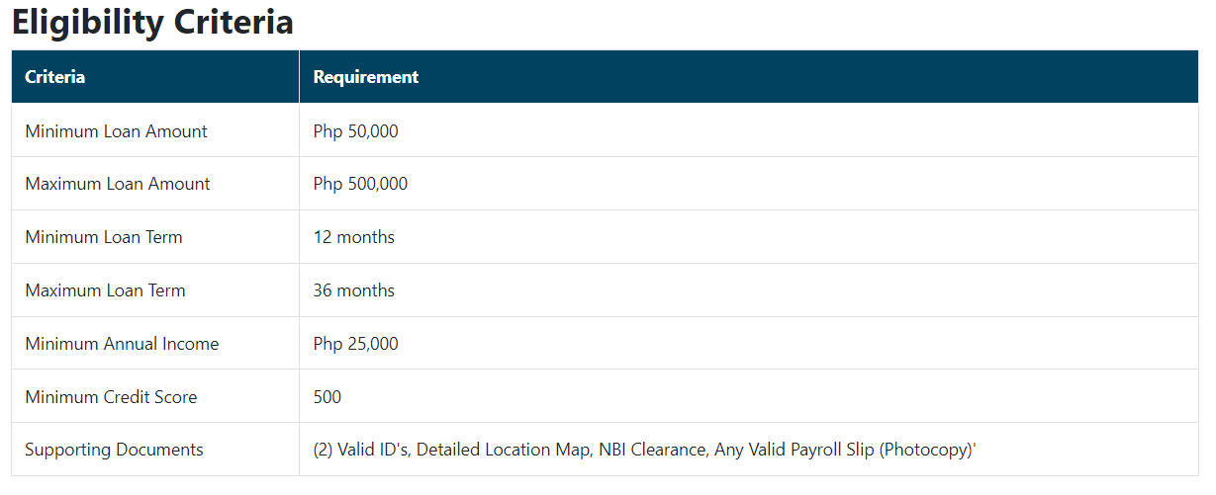

**Gadget Loan**

Users can check the specifics of their chosen gadget by making an account or entering in to an existing account on the gadget loan website, which displays the available gadgets for loan.  
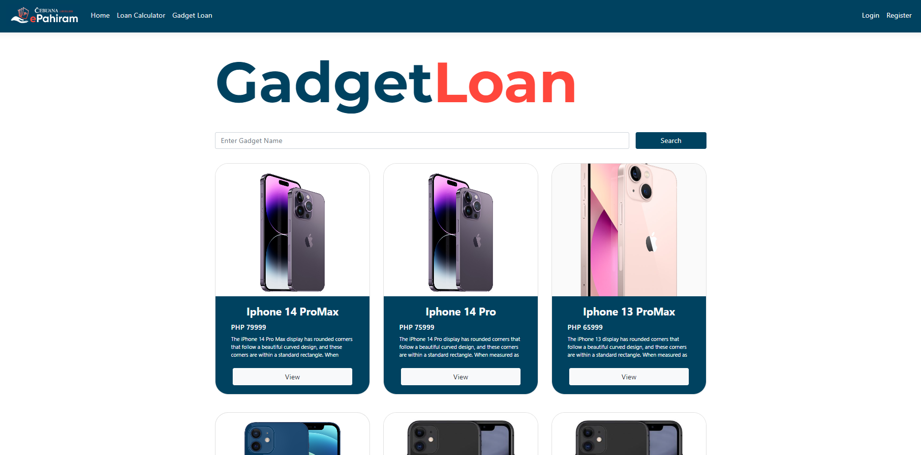

**Sign In Page**

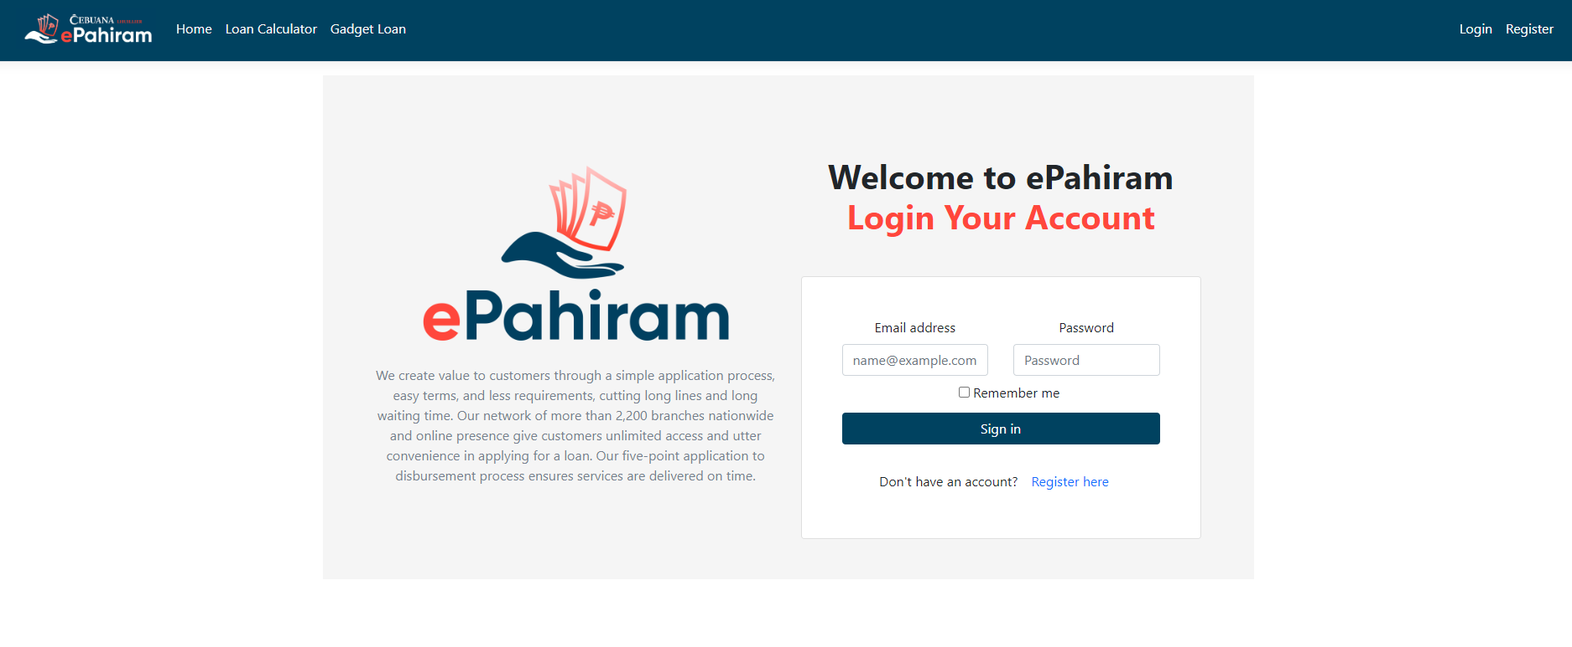

**Sign Up Page**

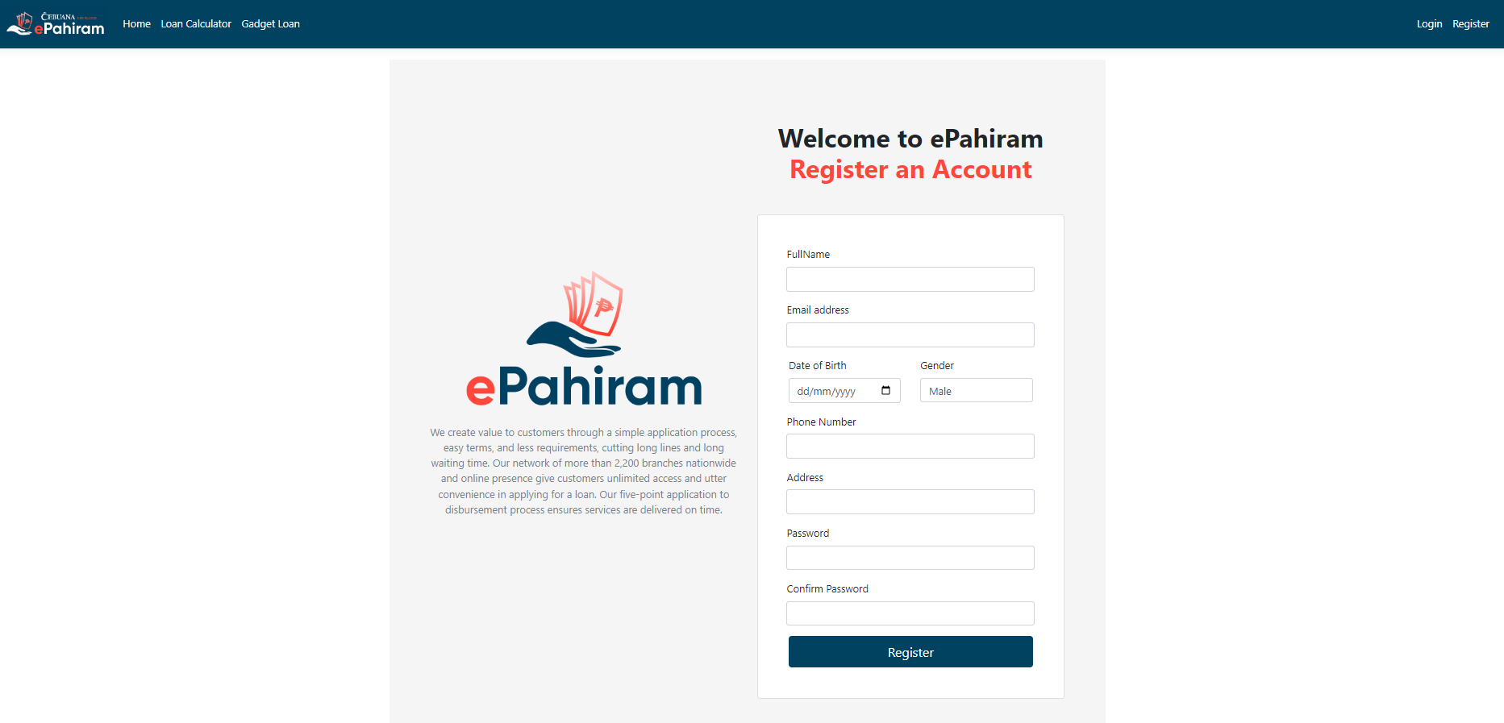

The system will assist in filling out the relevant information required in creating an account; there is a specific validation for each information the user is required to supplement in the provided entity.

**Once Sign In**

Users can use the search bar to hunt for their desired gadget and view its information. If they want to look at all of the gadgets, they can scroll down the page.

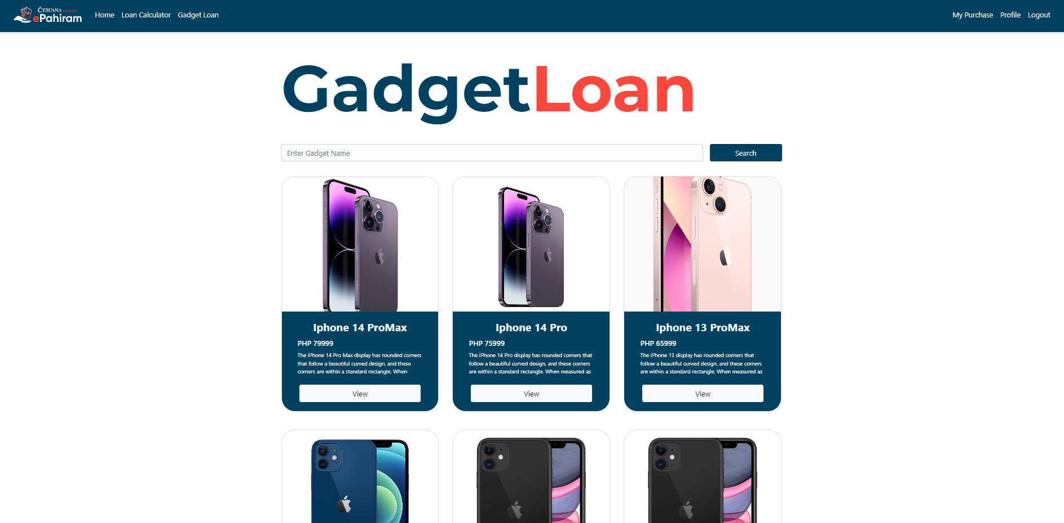

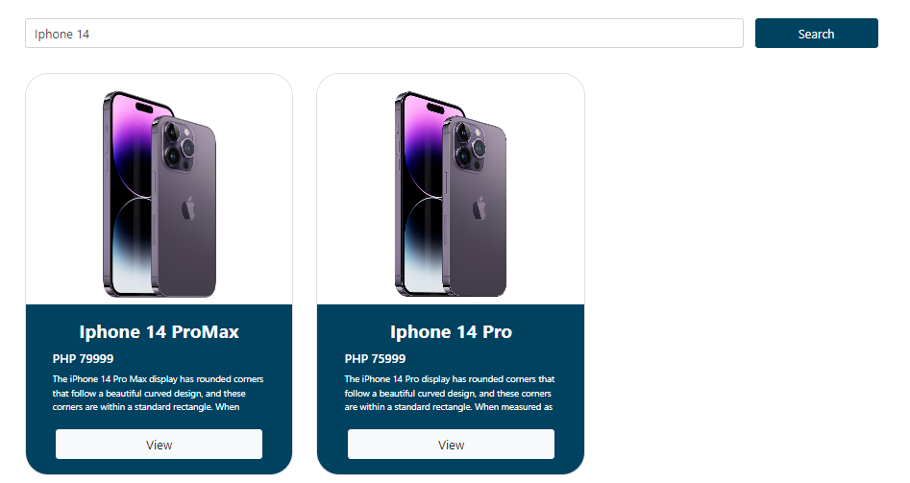

**On-View**

Users can view the overall information about the selected gadget as well as the payment terms. If the customer wishes to apply for a gadget loan, simply click confirm and the page will advance to the next view. (Before confirming, please select the payment term).

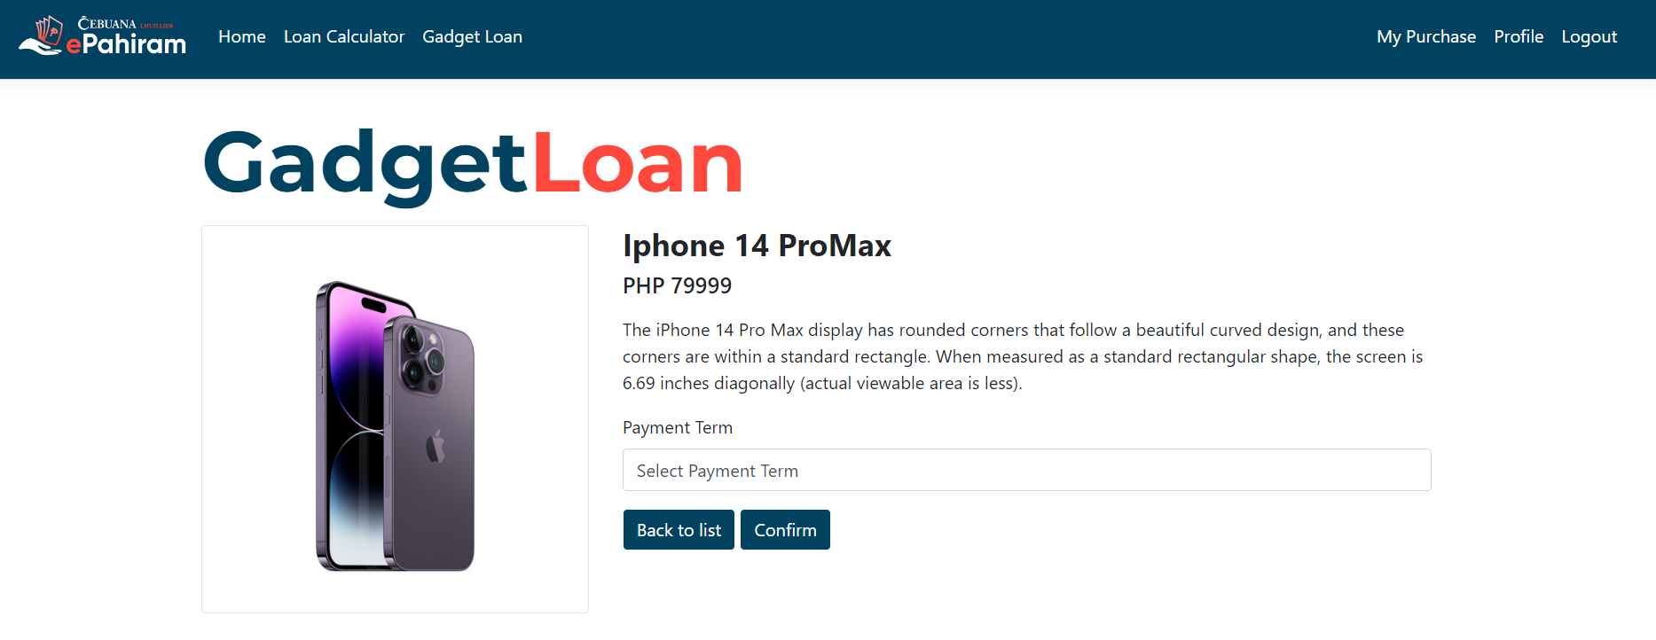

Following confirmation, it will navigate to the confirmation purchase, which displays the computation of the monthly payment based on the payment term selected by the user.

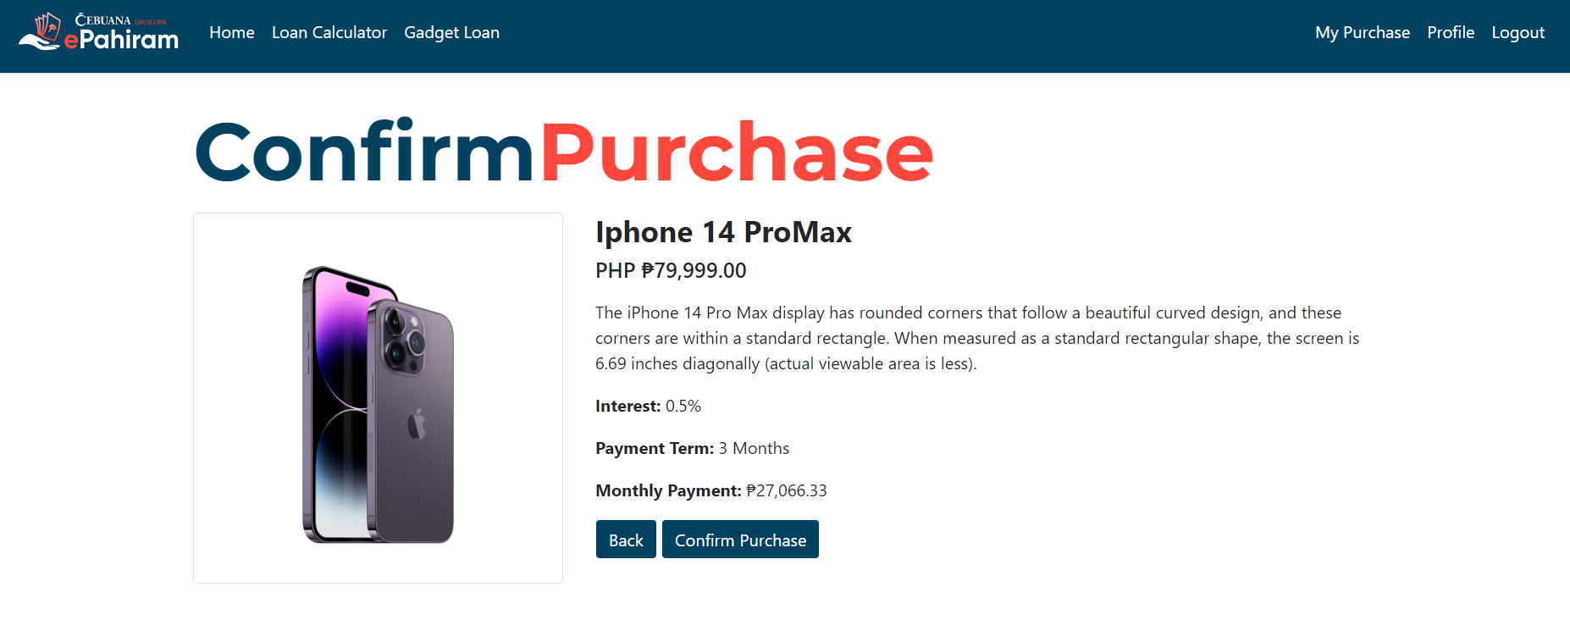

**After Successful Purchase**

The page will redirect to "My Purchase," where the user may examine his gadget loan status or withdraw the purchase.

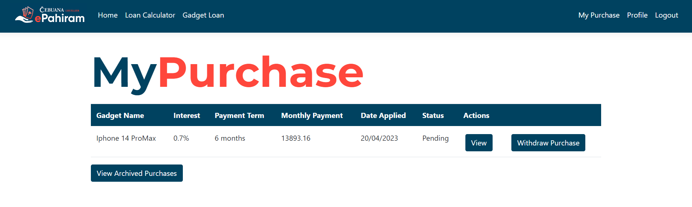

**Please keep in mind that** the system only permits one purchase per user, therefore if the user currently has a loan, the system will not enable the current user to purchase another device loan. Alternatively, the user can purchase another loan if the existing purchase is withdrawn (in this situation, the purchase can only be withdrawn if the status is "Pending", if the admin approves the purchase, the user cannot withdraw the current purchase).

**In another scenario**, if the admin declined the user's loan application, the user is permitted to purchase. All applications that have been withdrawn or declined will be viewable in the archived purchases.

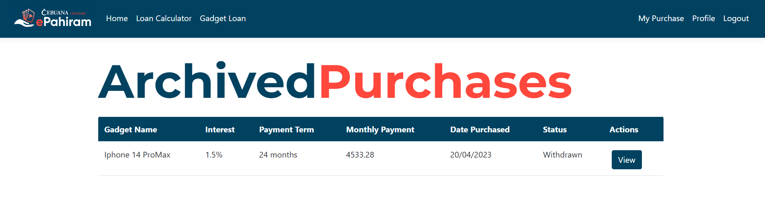

**User Profile**

Users can examine their information and change their password. (Note that the system will lead the user through the process of upgrading the password; the user must follow the criteria.)

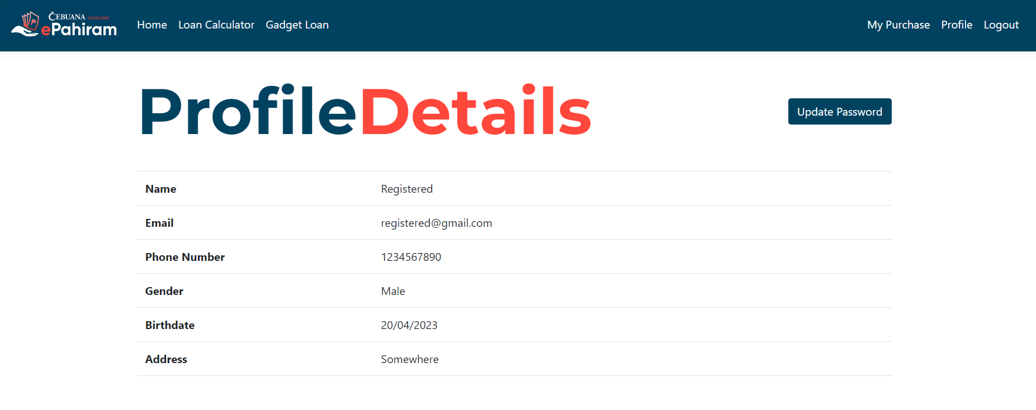

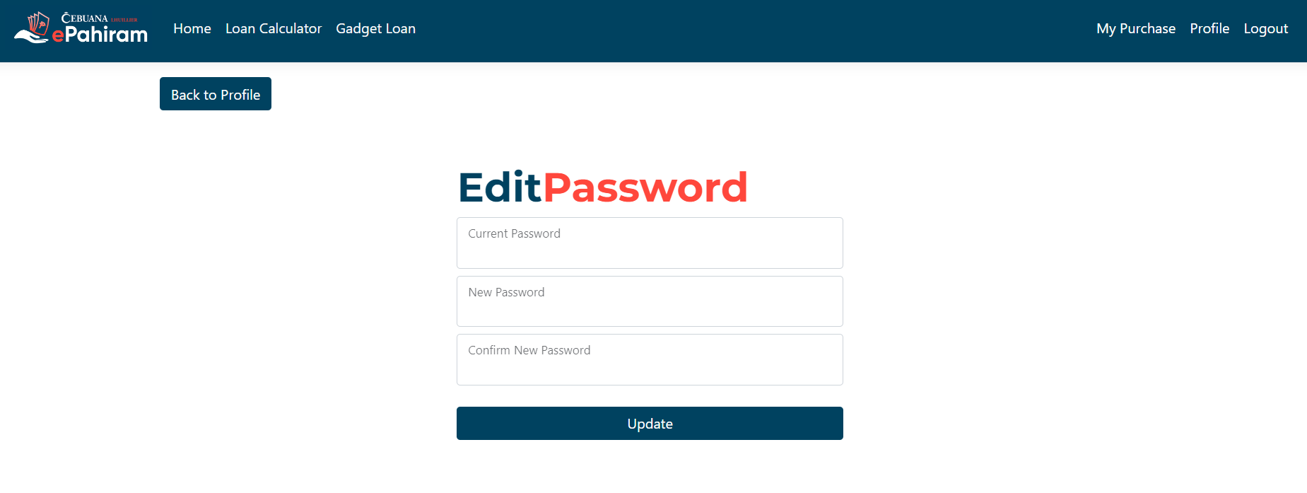

**Admin Guide**

**The administrator** may login to the application using the supplied administrator account.

The administrator can execute CRUD activities for the device loan after logging in; the system has already generated data for the gadgets. **Furthermore**, the administrator cannot delete a device if the user has already purchased it.

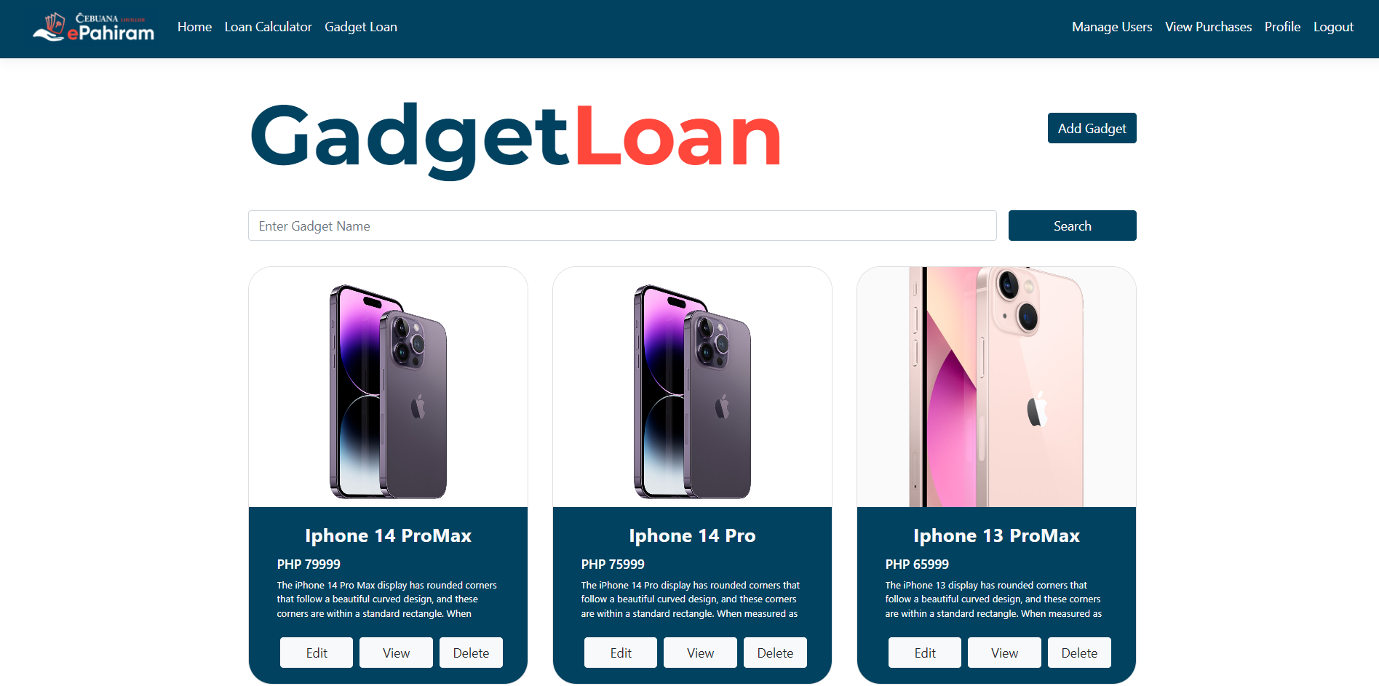

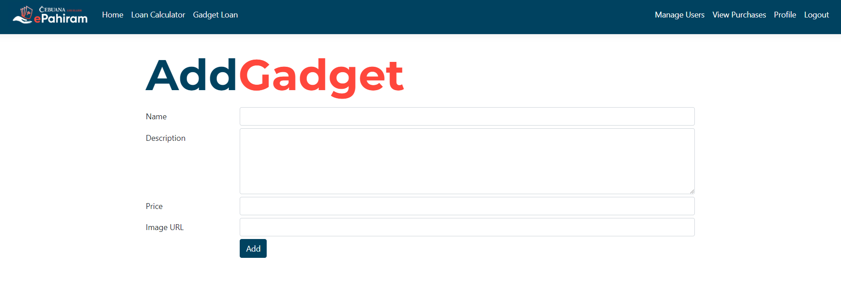

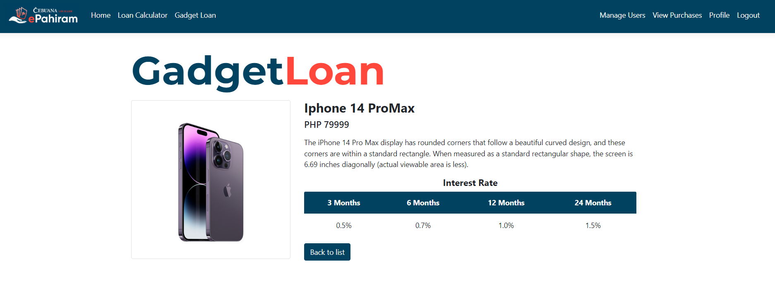

**Manage Users**

The administrator can view the information provided by the user during registration and, if necessary, remove the account.

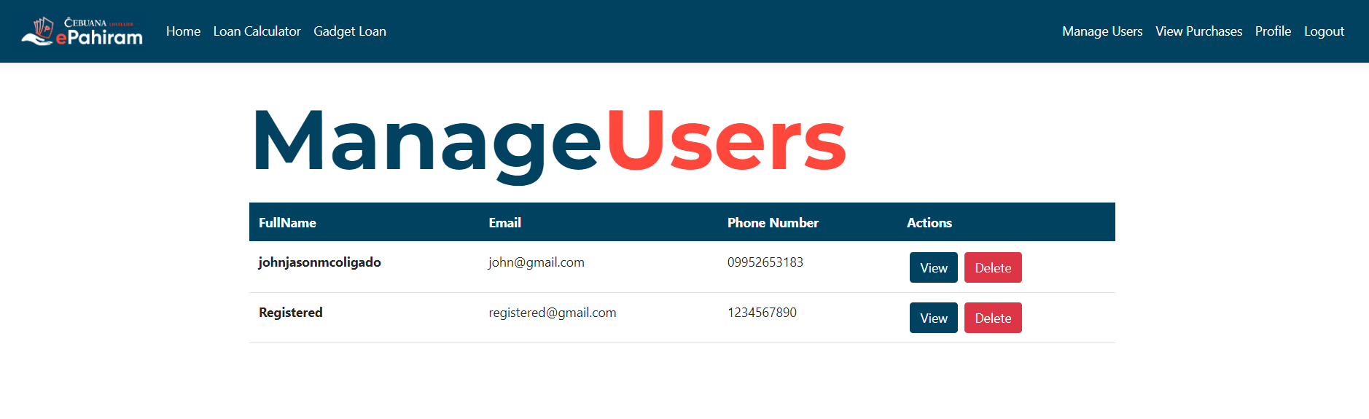

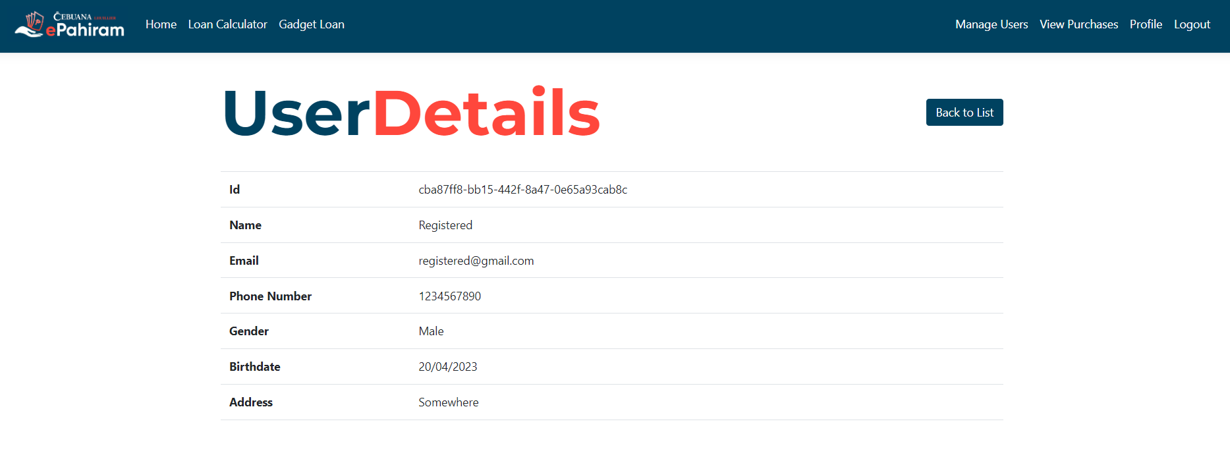

**Manage Purchases**

The administrator can check all of the user's existing purchases and manage the status of each program. Administrators can also see all withdrawn and denied transactions. Finally, **administrators can only delete archived purchases**, which will be reflected in the users' view of the archives.

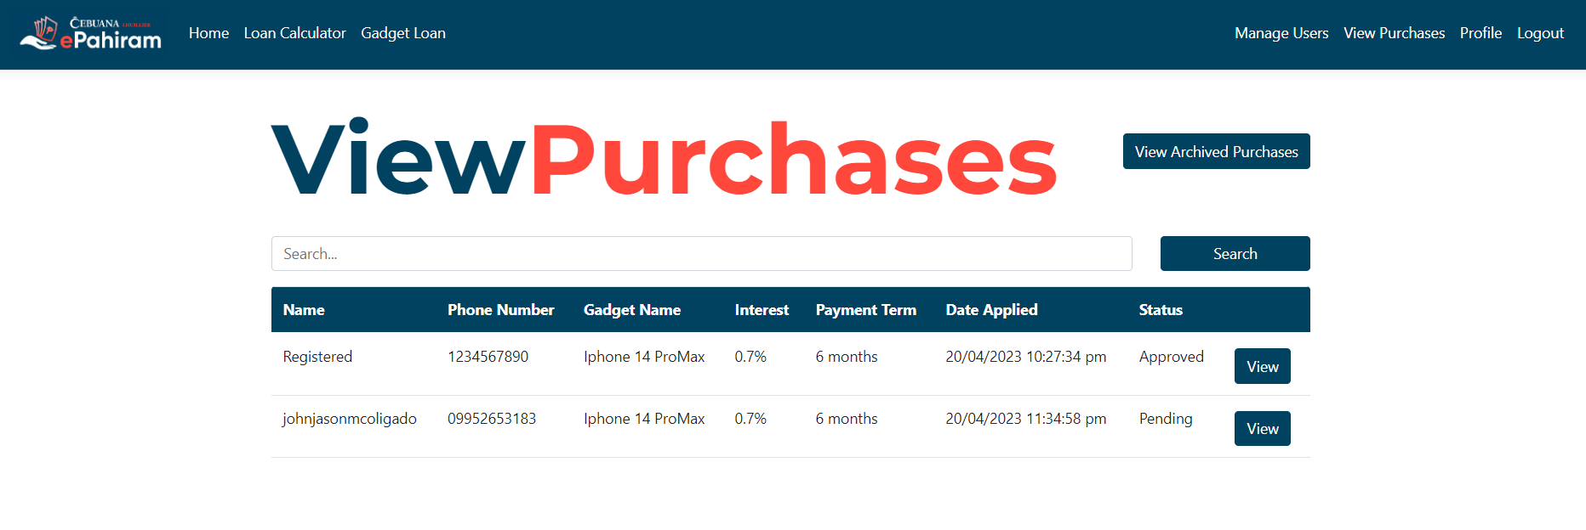

**Upon view**

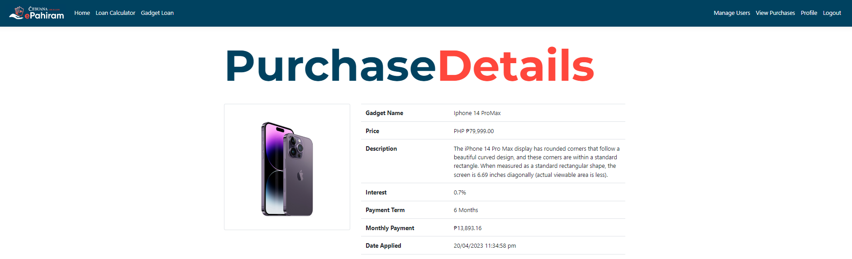

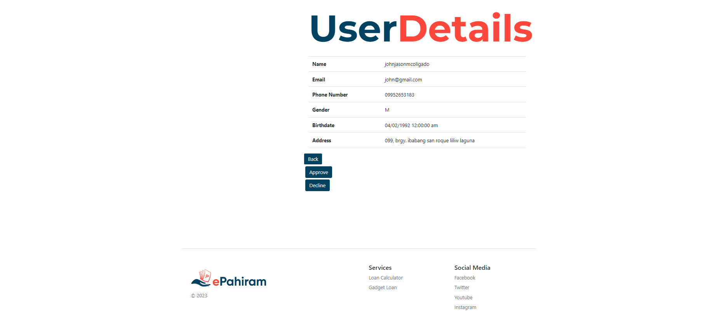

**Archived View**

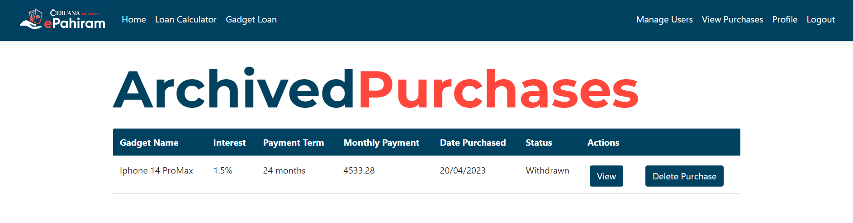

**API Documentation**

**Overview**

The ePahiram API is dedicated to the features of the gadget loan itself; its primary function is to perform CRUD operations for the system administrator; additionally, the API uses JWT token authentication for the security of API calls that may reflect changes to the main system.

**Tutorial**

The ePahiram API is built using the Asp.net framework and is powered by Swagger. Postman can also be used to make API requests. The API's major job is to support and perform basic CRUD operations for administrators, in which all populated data from the database can be updated, deleted, added new data, and read. We can use this to duplicate how the system performs based on the API operation.

Furthermore, the API is provided with authentication to prevent unauthorized access to its data; this ensures the API's credibility as well as the security of the system's database, as both the API and the system share the same database.

You can find documentation on how to consume an API in your system here. This link will walk you through what API is and how you can use it to meet your specific needs:

<https://blog.hubspot.com/website/application-programming-interface-api>

**Examples**

This section walks you through how the API works as well as a case-by-case demonstration of API calls using Postman.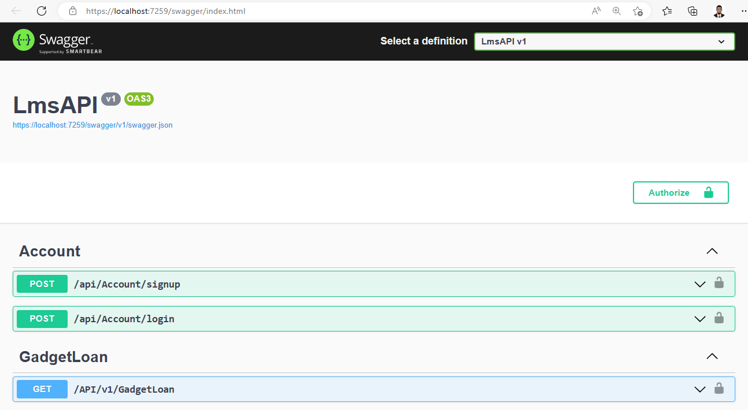

To understand how the API works, below is the API home page, which can be accessed using swagger. As you can see, there is an account preview where the API must demand you to login with your credentials, in this case the administrator account on your system.

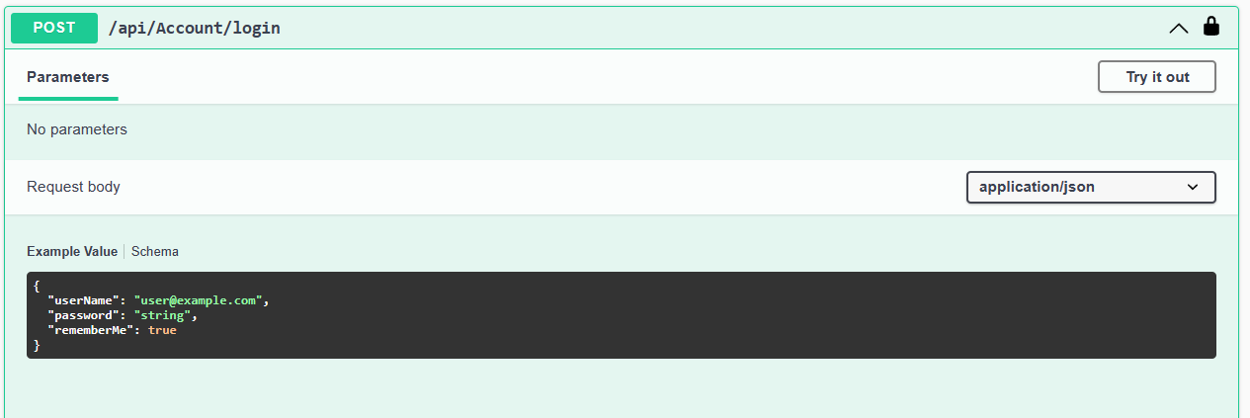

To be able to do API actions, the user must first log in; in this scenario, the account you will need to utilize is the **system administrator account**. Because the API and the system share the same account seed data. It should be noted that only the administrator has access to the API.

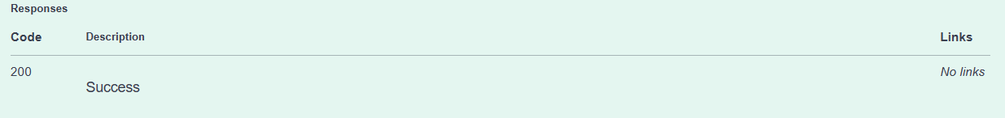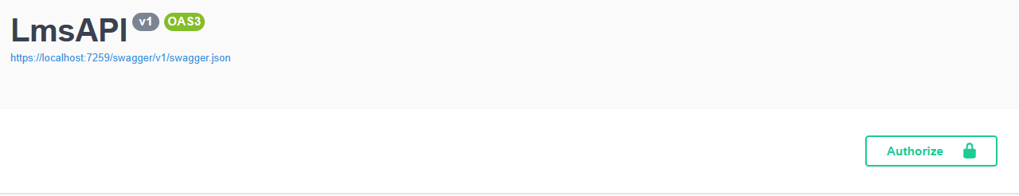

After a successful login make sure to copy the token id that the authentication given to you and paste in in the authorized dialog to login the API.

**Note:** If you receive a response code of 400, please carefully check your credentials; they must be the same as the account you are using in the system to receive a success response code of 200.

Below the accounts there is an area where you can see the **Gadget loan** this is where all the CRUD operation can be perform using API calls.

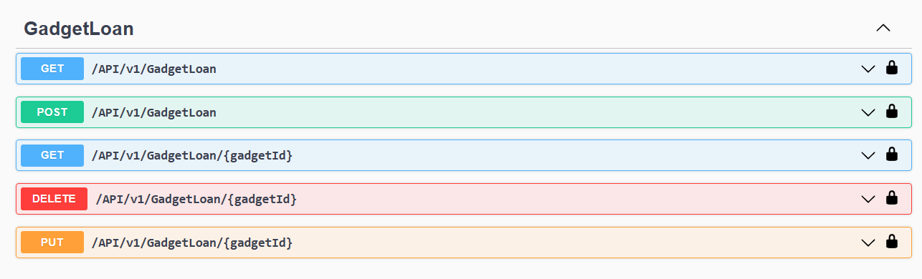

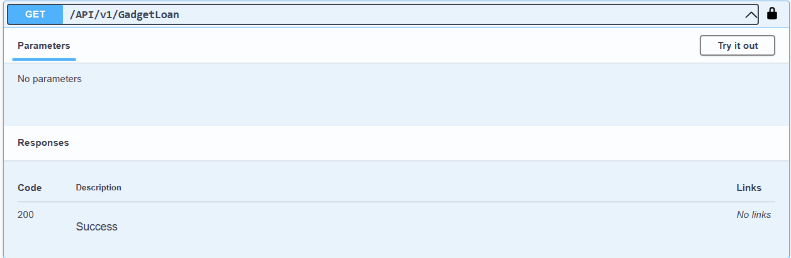

The http "get" function calls all of the existing gadgets in the database and displays all of the data relating to what it is calling; in this case, I will retrieve all of the essential information from the gadget loan table.

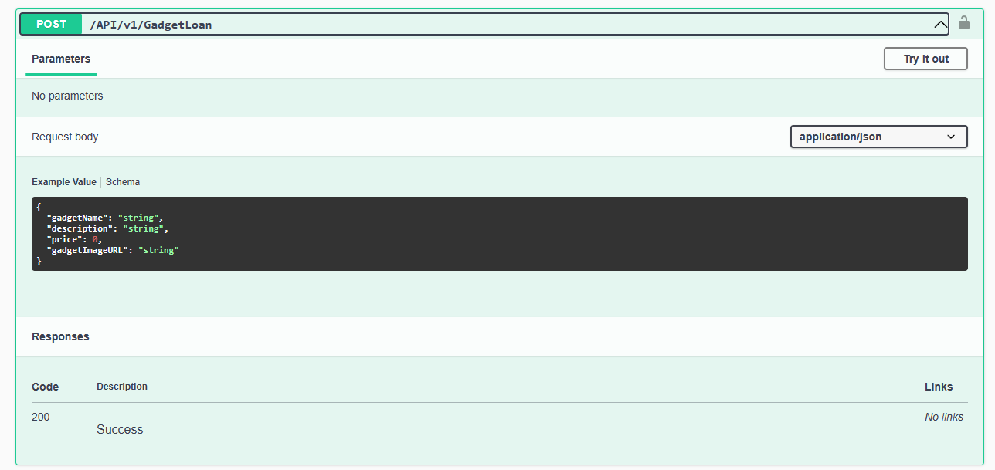

The http "post" method allows you to add another entity/data to the database; each type must be supplied correctly, and each input must be validated.

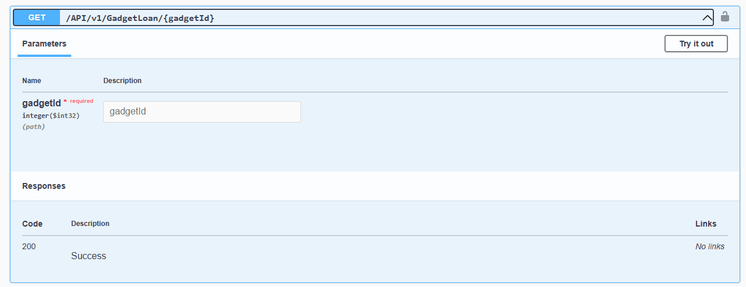

The http "get/gadgetid" query the specified input to the database; if the get method finds the given gadgetid, it will display the necessary information for the chosen gadgetid; if not, an error code of 500 will be displayed, indicating that the id was not found.

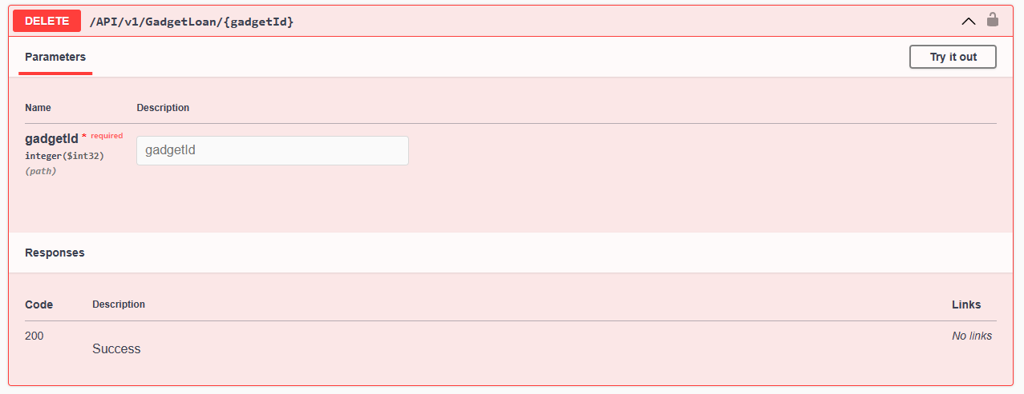

The delete http "post" will take the gadgetId provided and search the database for it; if the id is found, it will delete the entry to which the id is attached. Also, if the gadget id was not found it will return a message “Resource not found”.

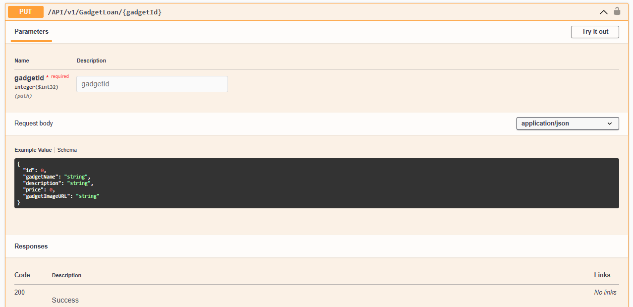

The http "put" command allows you to update an existing database entry using the entry's id. It should be noted that each item must adhere to the API's validation. Invalid entries are not counted as updates to the specified id.

**Glossary**

Packages to be installed:

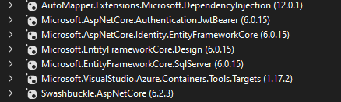

Tools & Frameworks:

* Asp.net core
* Asp.net Identity entity framework
* Auto mapper
* JWT authentication bearer

**GitHub Repository**

<https://github.com/JohnjasonMC/Micro-Loans.git>